Name: Thierry Abanenatwe
ID :28832

ASSIGNMENT DOCUMENT
This document contains all the screen shots showing the output of different queries aimed at increasing the performance of Kigali supermarket.
Company is Kigali supermarket a medium selling business
Department: analytics team
Industry: Grocery
The entity relational diagram drawn using draw.io website
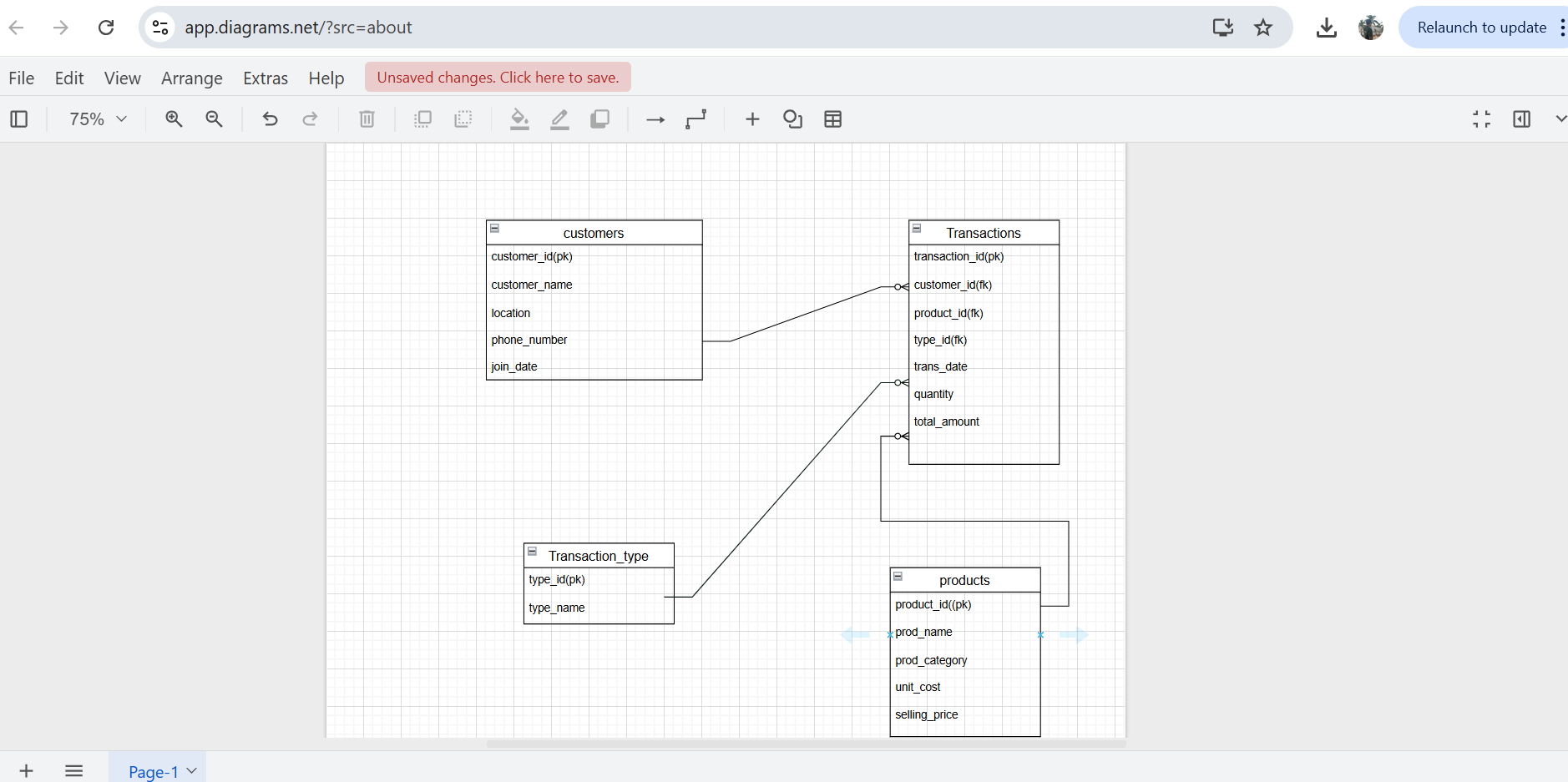

Different use of windows function
Ranking: ROW_NUMBER(), RANK(), DENSE_RANK(), PERCENT_RANK() Use case: Top N customers by revenue
- This query shows the rank , dense_rank, and row_number of customers base on there total spending or total number of transaction amount they made.
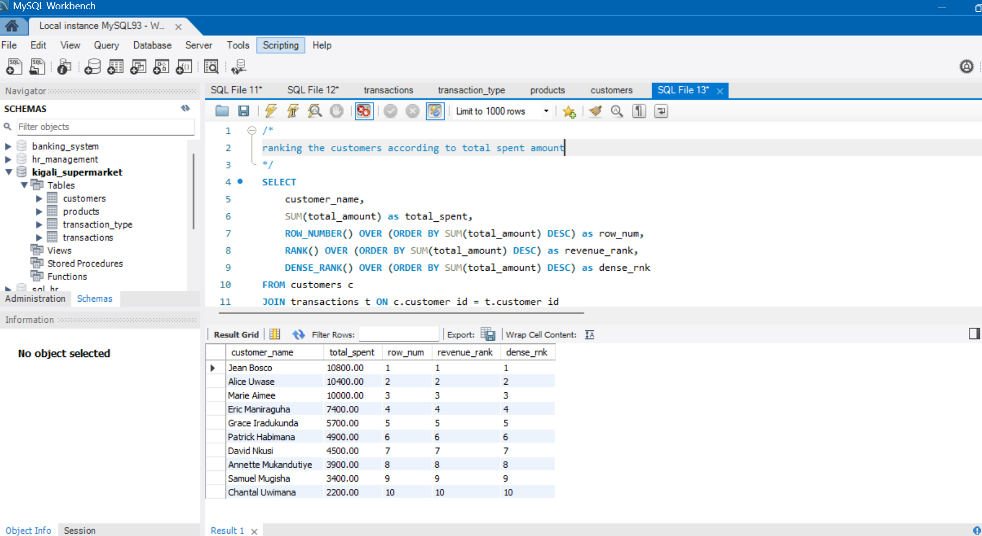

2.In this query we are listing the top 5 customers who make transactions with a lot of total amounts using the row_number function since we have no duplicates we can choose in one of the either rank, dense_rank or row_number.
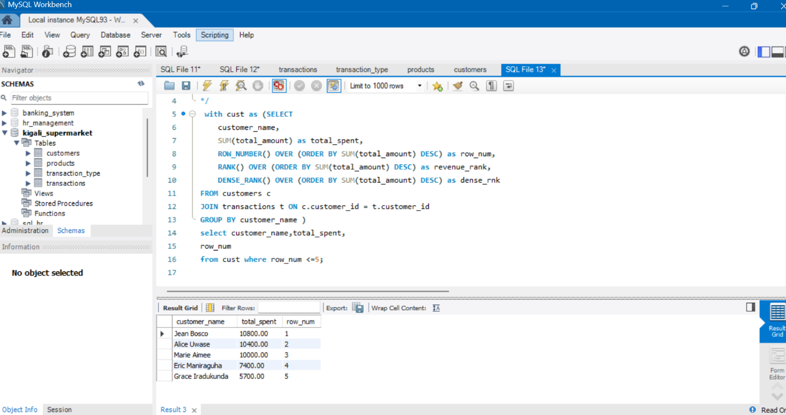
- This query ranks products within each category in the column of category_rank

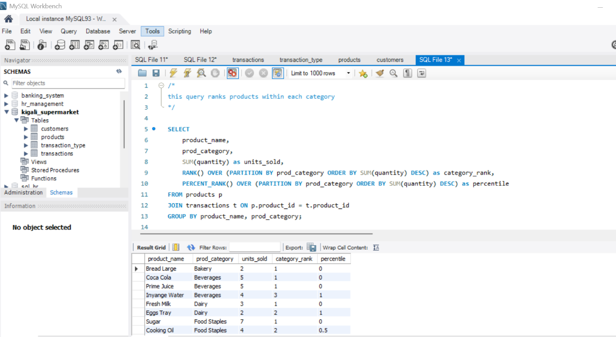

4.These query helps us to know in which month that we have made many sales using rank and dense_rank.

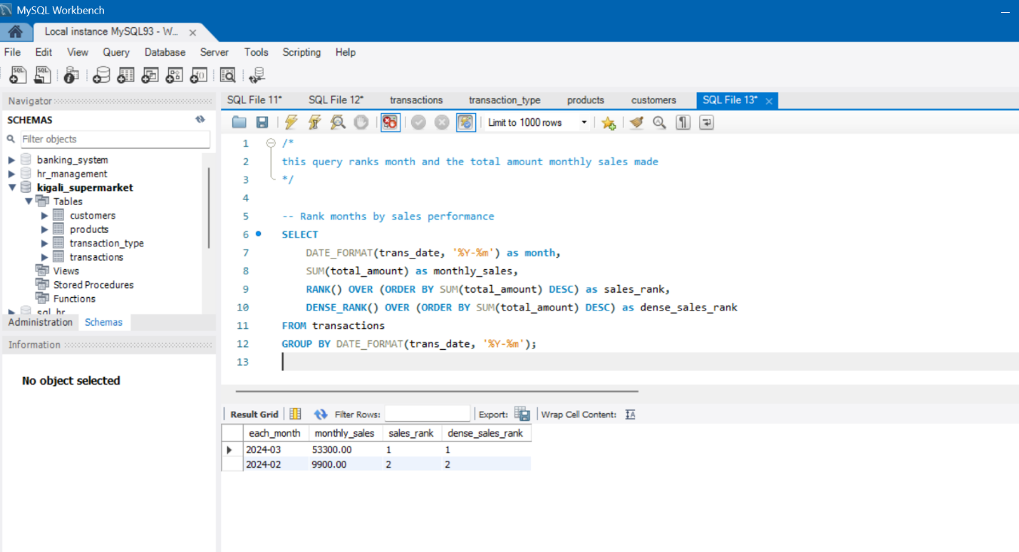

5. this query identifies which is the most payment method that is preferred by the
Customers
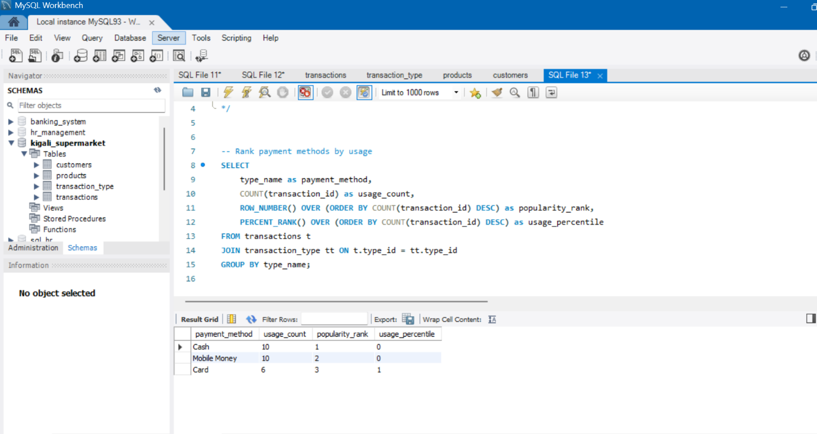

6.In this query we are identifying the customers who visit our supermarket many times using the rank function and dense rank function which means we can even find the top n customers.

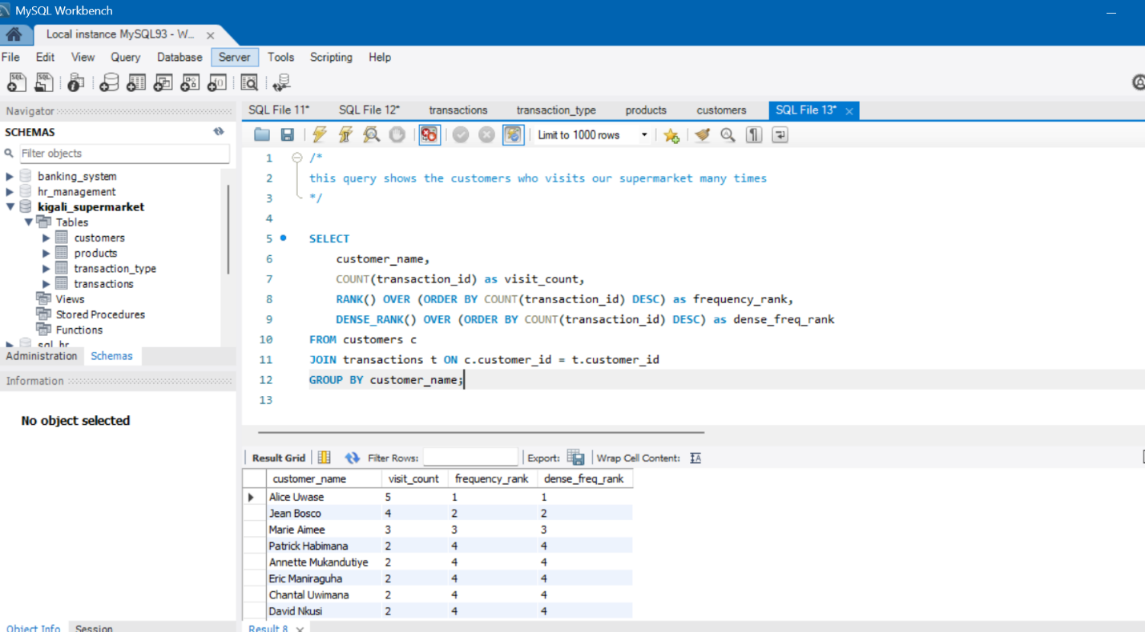

Using the aggregate function as window function (sum,min,max,avg).
7. This query shows the total amount that is spent every day using the sum as the window function
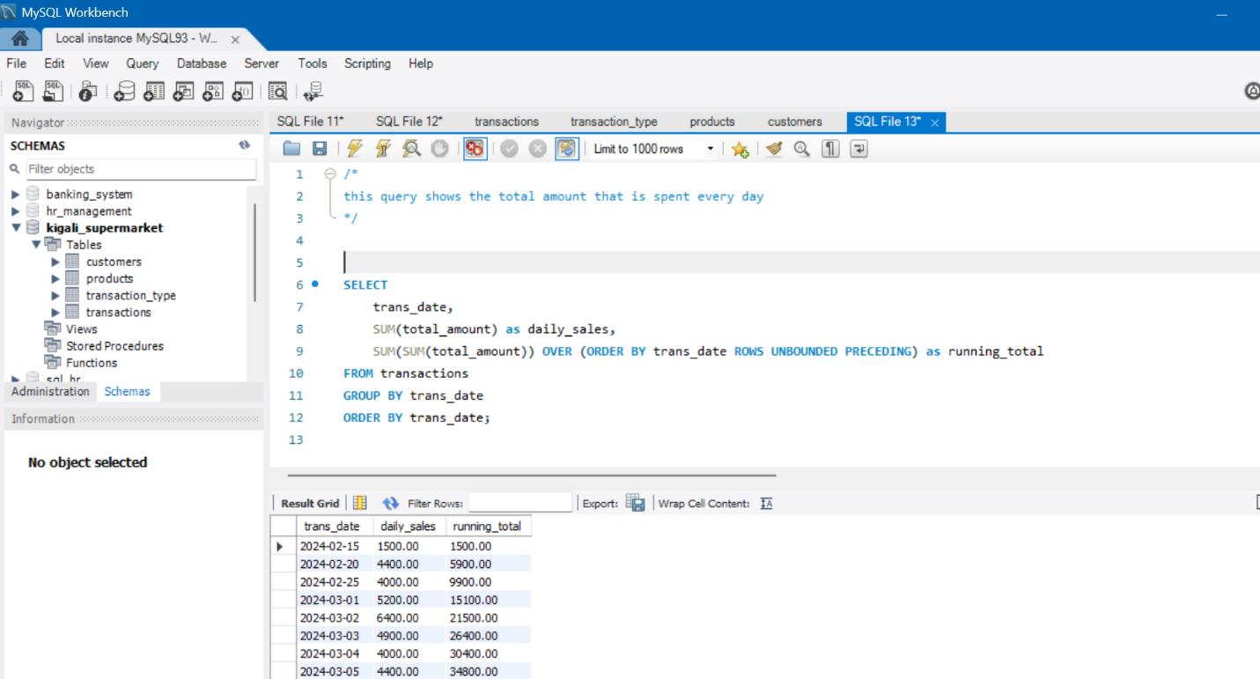
8. This table shows the 3_day moving average sales
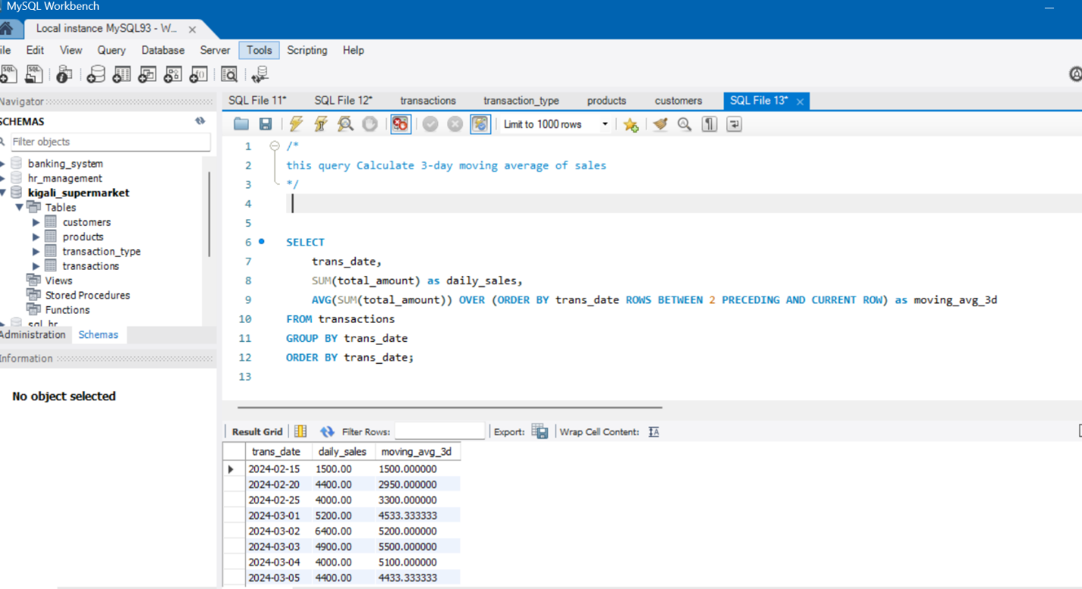

9. finding the min, max value per sale

10. In this query we are calculating the cumulative average of every customer by using there total amount in the transactions table
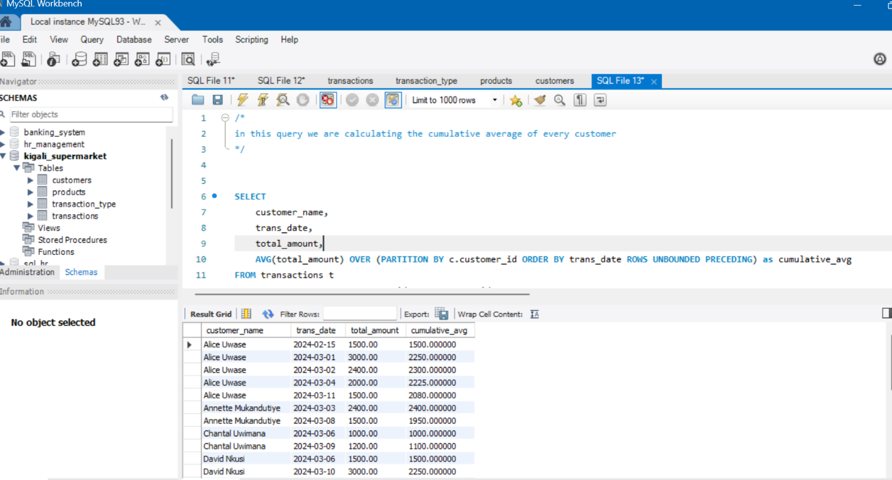
The navigation functions (Lead and Lag)
11. Here we are determining the monthly growth percentage by using the lag and lead window functions
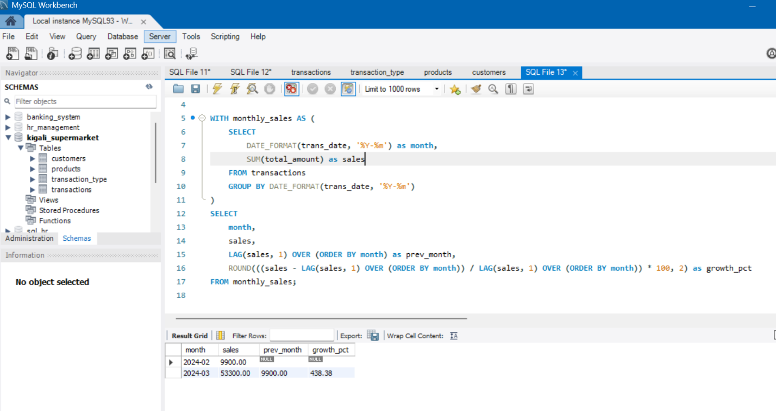
12. In this we are finding next purchase date for each customer using lead function
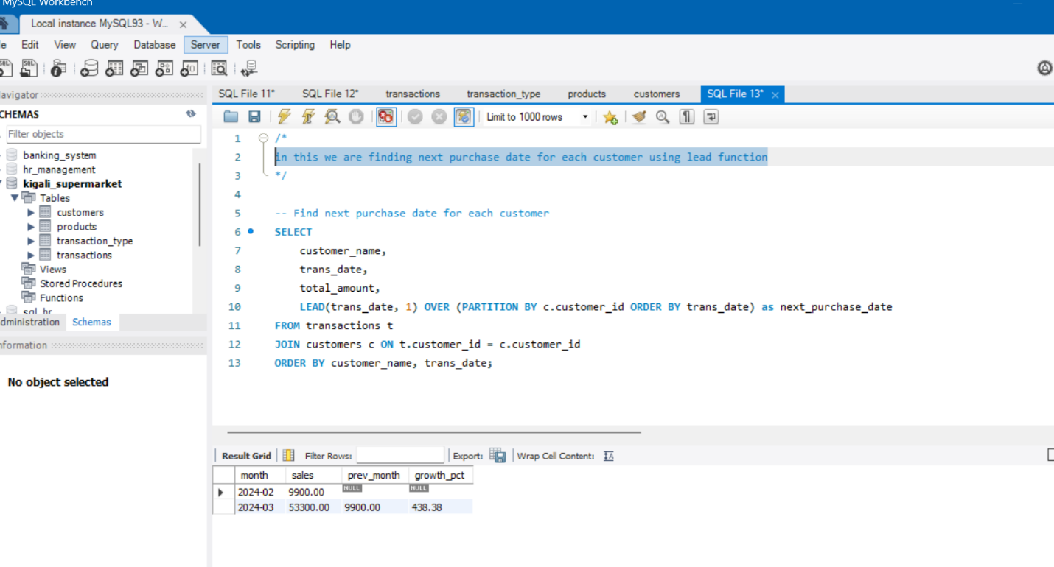

13. In this table shows each day's sales with previous day
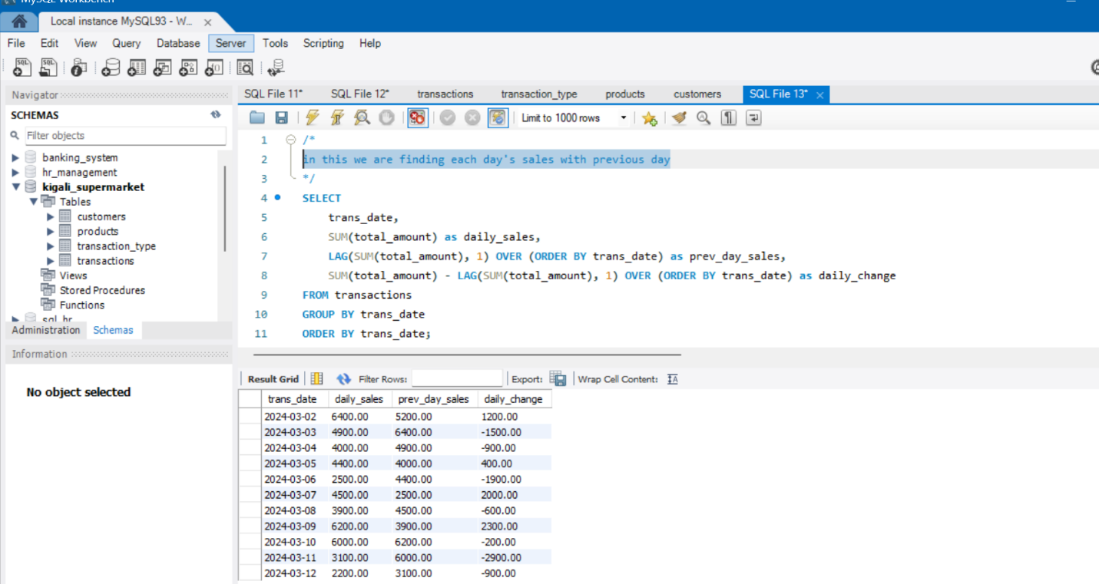
14. Here we are making analysis of product sales trend using the lag and lead windows function
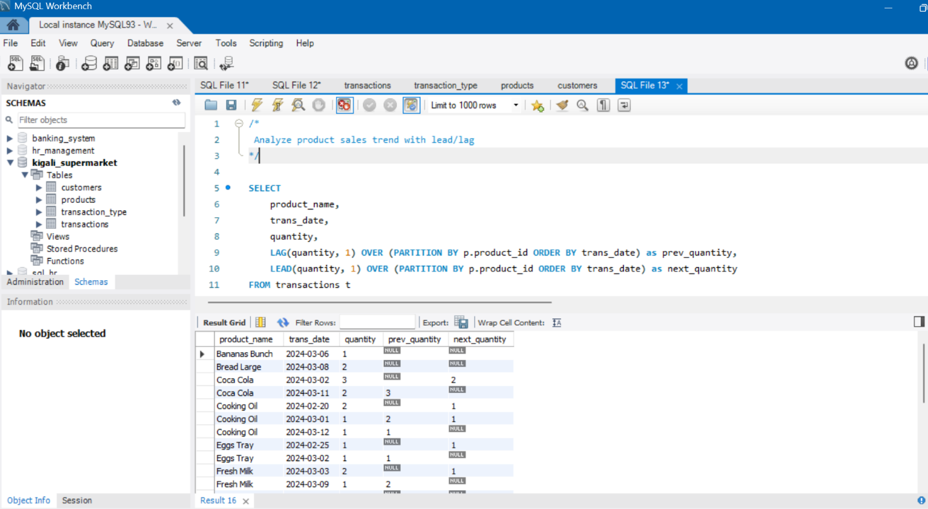

15.Making analysis of how different customers spend their money daily in our supermarket.
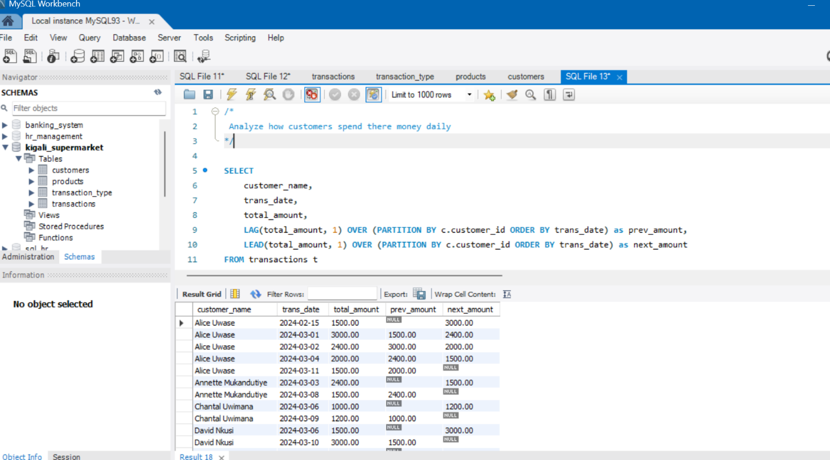
Distribution function (NTILE, CUME_DIST)
16. In this query we were segmenting the customer in 4 quartiles basing on the total amount they have so far spent.
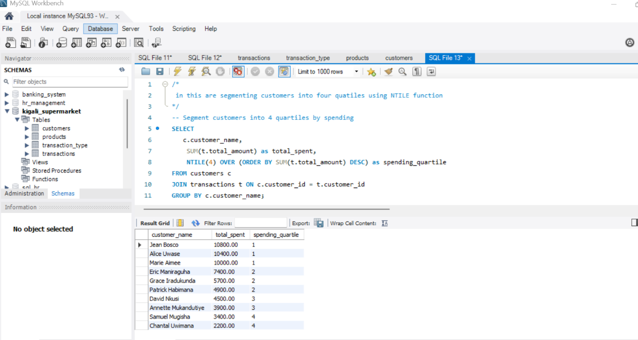
17. using the cume_dist function to analyze the performance of the product and its percentility

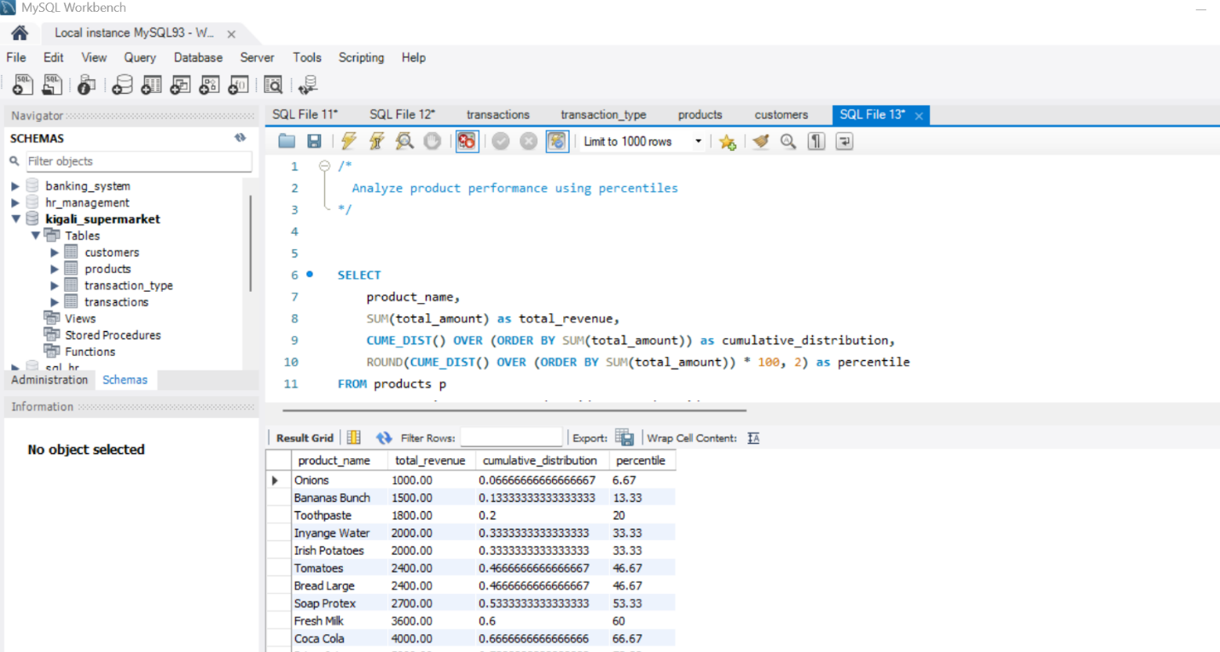
18. segmenting the customers based on there visits
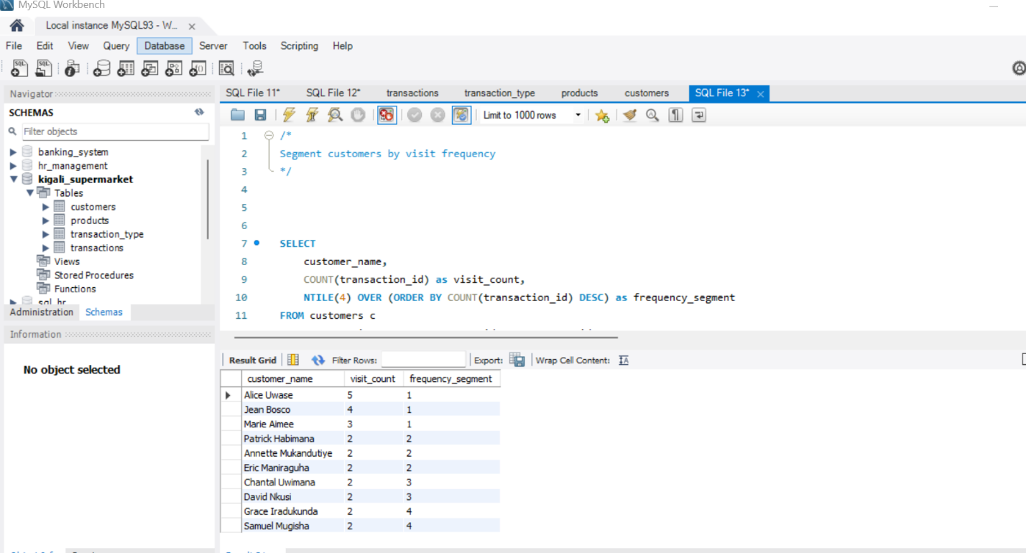
19.Analysing the payment method distribution using the cume_dist windows function
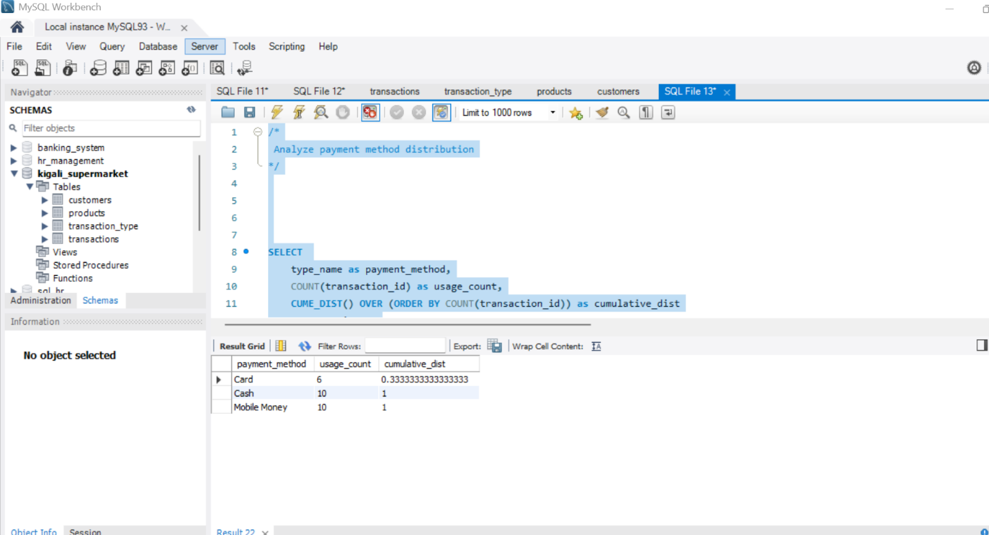

20.segmenting the products based on the price range
